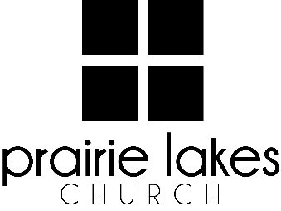

We are delighted you are considering an internship at Prairie Lakes Church! You can look forward to a challenging and rewarding year. Whether your passion is families, worship or administration, after spending a year with us, our goal is you will be more proficient with your skills, wiser as a leader and more mature as a follower of Christ.

**Overview:**

* You will be part of a cohort of 6-12 interns for the 2025-2026 academic year (August – May).
* You will be expected to invest a minimum of 10 hours per week during the semester.
* You will receive a stipend of $1600 per semester.

**Application Deadline:** February 21, 2025

Specific questions may be directed to Human Resources

[internships@prairielakeschurch.org.](mailto:internships@prairielakeschurch.org)

**Guest Services Intern**

This intern will report to the New Hampton Campus Pastor.

**Education, Experience and Skills Requirements:**

* Pursuing a degree from a college or university
* Exhibit evidence of a healthy and growing relationship with Christ
* Fully support the ministry philosophy of Prairie Lakes Church and its leadership team
* Exhibit evidence of strong relational skills
* Display evidence of strong writing skills
* Possess a strong work ethic with a demonstrated ability to initiate and finish projects

**Responsibilities:**

* Assist Guest Service Coordinator with weekend experience
* Oversee event coordination for First Step
* Invest in Guest Services volunteers
* Develop training resources for Guest Services volunteers
* Assist in helping guests take their first and next step
* Assist with communication-related responsibilities
* Assist in Next Steps data tracking
* Regular one-on-one meetings with New Hampton Campus Pastor

**Development:**

* Personalized leadership coaching & development meetings
* One-on-one mentoring
* Personalized StrengthsFinder coaching
* Exposure to all PLC campuses
* Attend retreats as scheduled