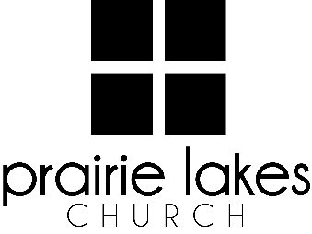

We are delighted you are considering an internship at Prairie Lakes Church! You can look forward to a challenging and rewarding year. Whether your passion is families, worship or administration, after spending a year with us, our goal is you will be more proficient with your skills, wiser as a leader and more mature as a follower of Christ.

**Overview:**

* You will be part of a cohort of 6-12 interns for the 2025-2026 academic year (August – May).
* You will be expected to invest a minimum of 10 hours per week during the semester.
* You will receive a stipend of $1600 per semester.

**Application Deadline:** February 21, 2025

Specific questions may be directed to Human Resources

[internships@prairielakeschurch.org](mailto:internships@prairielakeschurch.org).

**CS Social Media Intern**

This intern will report to the Director of Marketing and Communications

**Education, Experience and Skills Requirements:**

* Pursuing a degree from a four-year college or university
* Exhibit evidence of a healthy and growing relationship with Christ
* Fully support the ministry philosophy of Prairie Lakes Church and its leadership team
* Possess strong communication skills
* Exhibit evidence of strong relational skills
* Possess a strong work ethic with a demonstrated ability to initiate and finish projects
* Experience in marketing or journalism
* Experience with social media, include Facebook and Instagram
* Familiarity with digital communication/marketing tools or desire to learn them.

**Responsibilities:**

* Monitor the Prairie Lakes online and social media presence to accurately reflect the mission and vision of Prairie Lakes Church.
* Capture photo/video content for web and social.
* Schedule posts and content for Prairie Lakes Church’s various social media platforms
* Curate successful content examples and adapt them for Prairie Lakes Church.
* Manage website events and edits.
* Contribute in developing overall platform strategies and aesthetics.
* Learn and assist PLC’s marketing strategies and campaigns.

**Development:**

* Personalized leadership coaching & development meetings
* One-on-one mentoring
* Personalized StrengthsFinder coaching
* Exposure to PLC campuses
* Attend retreats as scheduled